In preparation of your IAPro scheduled installation it will be necessary to download the installation files. The downloading of these files should be done the day before or the day of the scheduled installation, this will ensure that you are installing the latest versions of our software. Note, a member of our company would be very happy to perform the installation remotely using GoToMeeting.

The applications files download requires having a login to our application server https://unite.iapro.com.

CI Technologies has to create the user account login we will need your IT support personnel full names and email addresses to add as contacts to your agency record after which you will receive an email with the login information.

For agencies installing for the first time you will need the following from our Unite Server.
- SQL Database files
- CI Manager
- IAPro Windows install files
After downloading check the properties of the files to insure they do not need to be unblock if they are blocked on the general properties page you will see Unblock at the bottom click on it to remove.

Database Schemas

Once you have your Unite login the below link will download the database schemas.

For SQL Server 2012/2014/2016/2017/2019: https://unite.iapro.com/api/application-version/9af3a469-a795-4995-9e21-bbf3bf4d7eab/download

The downloaded zip file will contain the instructions document, two database backup files to restore to your SQL instance.

IAPro Client

Downloading the IAPro Client login to Unite with your user account then click on the IAPro Windows 7.4 under Applications.

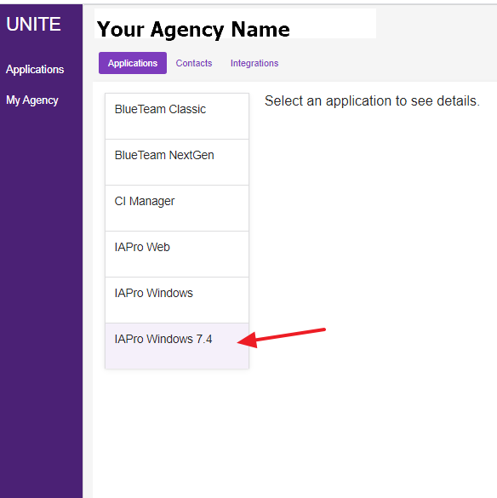

In the upper right window click again on IAPro Windows 7.4 to take you to the download files.

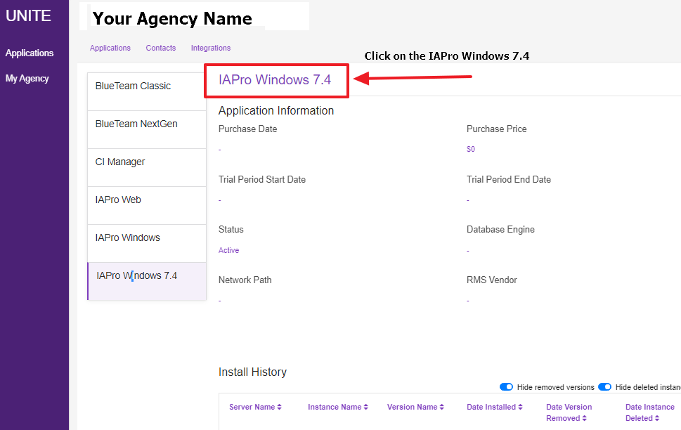

Download the New Install, it is a zip file that contains the installation document, SQL Native Client 11 MSI installer for both 64bit and 32bit OS along with the IAProInstall74.MSI installer.

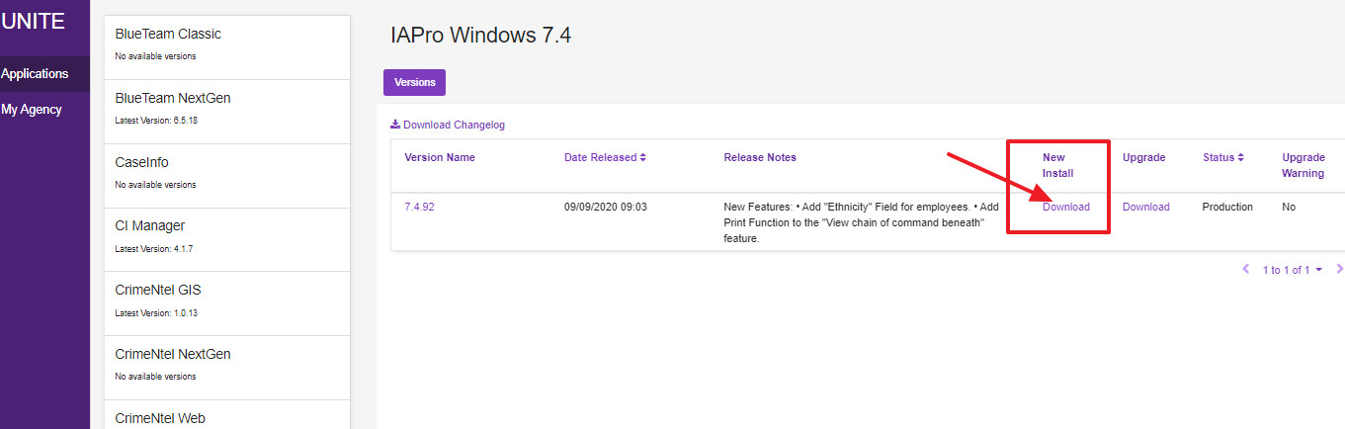

Microsoft SQL Native Client 11 ODBC Driver Required:

Updating to using the SQL Native Client 11 driver that supports TLS 1.2 requires (ensuring) that the latest SQL Native Client 11 driver is installed on the workstation MSI installer included with the IAPro client files.

IAPro Web and BlueTeam (If purchased) Installation:

Please refer to the CI Manager Web App Install Guide for instructions installing and configuring these applications.

CI Manager App Install Guide:

http://iaprofessional.com/webfiles/Manuals/CI%20Manager%20Web%20App%20Install%20Guide.pdf

CI Manager Download: https://unite.iapro.com/api/application-version/1ad8813f-cdaa-41cc-9a3d-69983372330a/download

